# Problem 01

## Code

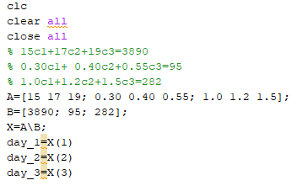

## Output

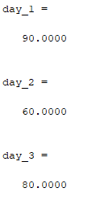

# Problem 02

## A)

### Code

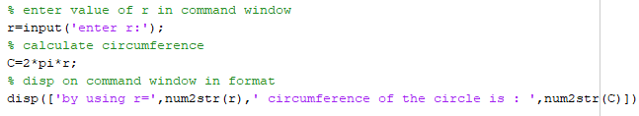

### Output

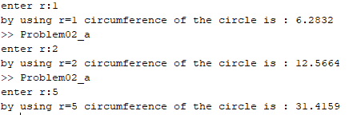

## B)

### Code

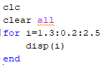

### Output

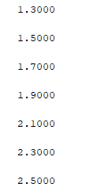

# Problem 03

## A)

For the sum of integer from 1 to 50 we can use for loop. Which add every time I in sum and give sum. For loop only use when we know the number of iteration and in case we know very well

Another we can use the build in function also. In matlab we have a function which take array of number and return the sum of all these values.

## B)

For the case we can use the while loop. Because we don’t know the number of iteration and while loop compare the input value until string is not enter.

## C)

For the 10 number we can use for loop as well while also but according to definition for loop is best. And for the average we can also use another loop outside loop because we can find average when we can all 10 values, second way to find the average we can use the build in function also. We can find the number which are greater than average by loop and we can also use find function for this also

### D)

We can use while loop for the positive integer and when integer is positive, we can break loop otherwise repeat and take n as input again and again.

When we have n is positive number, we can generate random number by using randi([10,20],[1 n]).